For reactive learners, becoming more autonomous seems to imply two things. Firstly, there is the need for a change in receptions about what language learning involves and a change in the expectation that language can only be learned through the guidance of a specialist teacher. Secondly, there is the need for acquisition of techniques with which learners can manage their self-directed learning. Holec (1980) regards the learning process as a management process and includes the following among the necessary techniques of management: fixing objectives for learning, deciding on the content of a learning program, selecting methods, self-monitoring of progress, and self-evaluation.

The teacher, then, might be assumed to have a responsibility for fostering autonomy through a process of learner training. This can be defined as a set of procedures or activities which raise learners' awareness of what is involved in the process of learning a second language, which encourage learners to become more involved in and responsible for their own learning, and which help learners to develop and strengthen their strategies for language learning.

Much of the research into learner strategies has held in view the perspective of the self-directed language learner, and has tried to establish whether it is possible to facilitate learning through the use of certain strategies or whether learners can modify their strategies and learn new, more effective ones. More work is currently needed in the field to investigate learner training for strategy use. Pedagogically speaking, there are now available discussions and suggestions for learner training programmes and materials. For example, Dickinson (1987) identifies two areas of preparation for self-directed learning: psychological preparation (i.e. building confidence to work independently of the teacher), and methodological preparation (i.e. acquiring the necessary abilities and techniques for such activities as self-evaluation). Other recent discussions of training, e.g. Ellis and Sinclair (1989) and Wenden (1991), are informed by strategy research: these attempt to provide a framework for learners to exploit in making their classroom learning more effective, and in building confidence and competence for more independent learning.

2.3 Learner strategies

Rubin (in Wenden and Rubin, 1987) defines learner strategies as 'any set of operations, steps, plans, routines, used by- the learner to facilitate the obtaining, storage, retrieval and use of information. That is, what learners do to learn and do to regulate their learning'. There is a useful distinction here between cognitive strategies (what learners do to learn) and metacognitive strategies (what learners do to regulate their learning).

Cognitive strategies are thought processes used directly in learning which enable learners to deal with the new information presented in tasks and materials by working on it in different ways. Analogy can be seen as part of the general strategy of deductive reasoning (Rubin, 1987); i.e. looking for rules in the second language on the basis of existing knowledge about language. Examples of other cognitive strategies are repetition, i.e. imitating a language model, and inferencing, that is making guesses about the form or meaning of a new item of language. Thus a learner might guess the meaning of 'drawer' in the sentence 'He kept the papers safely in a locked drawer of the desk' from the linguistic and meaning relationship between 'locked' and 'drawer', from the meaning link with 'safely', and from knowledge about the structure of desks and the nature of their use.

Metacognitive strategies involve planning for learning, thinking about learning and how to make it effective, self-monitoring during learning, and 'selfevaluation of learning after the language activity is completed' (O'Malley and Chamot, 1990). So, when learners preview the next unit of their course book, revise vocabulary noted down during a class, or read carefully through the teacher's comments on their written work, they are using metacognitive strategies to assist them in their learning.

Two other categories are sometimes included in frameworks of learner strategies. When learners use gestures, mime, synonyms, simple explanations, paraphrases, and cognate words from their first language to make themselves understood and to maintain a conversation despite the gaps in their knowledge of the second language, they are using communication strategies. The value of these is that they keep learners involved in practising the language. A further category relates to social strategies, those which provide learners with opportunities for practice, for example, initiating conversations with native speakers.

Early researchers into learner strategies (e.g. Naiman et al., 1975) acknowledged that observation alone yielded insufficient information about strategies, and consequently used interviews with learners. The last decade has seen a growing interest in using learners' introspections, and learner reports have formed a major research instrument. However, this approach is problematic and limited, as it can only investigate conscious strategies: research in the field still needs an effective methodology.

There are additional problems for those who wish to investigate the literature on learner strategies. For example, there has been a proliferation of terms such as 'tactics', 'plans', 'techniques', and 'language processing strategies' with no easy equivalences among them. Also, different research studies have identified different strategies and different ways of categorizing strategies, so a variety of frameworks has developed. The following part of this paper presents different taxonomies of strategies as categorized by the leading figures in the field of language learning strategies.

2.4 Defining Language Learning Strategies
The Longman Dictionary of Applied Linguistics defines Language Learning strategy as “a way in which a learner attempts to work out the meanings and uses of words, grammatical rules, and other aspects of a language, for example by the use of GENERALIZATION and INFERENCING”.
As to Brown, strategies are special “attacks” that one makes on a given problem. They are the moment by moment techniques that one employs to solve “problems” posed by second language input and output. (1994:114)
Cook defines learning strategy as “a choice that the learner makes while learning or using the second language that affects learning.” (1991:78)
According to Oxford, learning strategies are operations employed by the learner to aid the acquisition, storage, retrieval, and use of information. (1990:8)

Oxfords definition includes both psychological and physical aspects of language learning. It describes Language Learning as a process of input (acquisition), processing (storage and retrieval), and then output (use of information). Therefore, this definition is going to be adopted in this research.

Based on all the above attempts to define what a Language Learning Strategy is, (Smith M. 1994) drew his understanding of learning strategies as:
“The term ‘strategy’ should be understood as an organised approach to a task whether or not the language user is aware of applying the strategy in a given context, whether or not that strategy is part of a stable repertoire of strategies possessed by the learner or an ad-hoc invention on the spur of the moment, and whether or not the idea behind the strategy is to facilitate acquisition or simply communicate at a given moment on a time.”
(Smith M. 1994)

2.5 Characteristics of Language Learning Strategies
Language learning strategies have a number of basic characteristics accepted by the scholars in the field. Oxford (1990) lists twelve key features of Language Learning Strategies:
• Contribute to the main goal, communicative competence.
• Allow learners to become more self-directed.
• Expand the role of teachers.
• Are problem oriented.
• Are specific actions taken by the learner.
• Involve many aspects of the learner, not just the cognitive.
• Support learning both directly and indirectly.
• Are not always observable.
• Are often conscious.
• Can be taught.
• Are flexible.
• Are influenced by a variety of factors.
(Oxford, 1990, p. 9)

2.6 Categorizing Language Learning Strategies
Language Learning Strategies have been classified by different scholars in the field. The most famous classifications are those of Rubin (1987), O’Malley and Chamot (1990), and Oxford (1990). These taxonomies are going to be examined more deeply in the following parts.

2.6.1 Rubin’s Classification
Rubin (1987) was the first to draw a distinction between the direct and indirect strategies. Direct strategies are those which contribute directly to learning, while the indirect ones contribute indirectly to learning. Rubin (1987) defines three types of strategies used by learners that contribute directly or indirectly to language learning.

Rubin’s first category is called Learning Strategies. It consists of two main types Cognitive and Metacognitive Learning Strategies. They are thought to be strategies directly contributing to the language system constructed by the learner. Cognitive Learning Strategies refer to the steps or processes used in learning or problem-solving tasks that require direct analysis, transformation, or synthesis of learning materials. Rubin (1987) identified six main Cognitive Strategies which directly contribute to language learning: Clarification/Verification, Guessing/Inductive Inferencing, Deductive Reasoning, Practice, Memorization, and Monitoring. Metacognitive Learning Strategies are used to supervise, control or self-direct language learning. These strategies involve a variety of processes as planning, prioritizing, setting goals, and self-management.

Communication Strategies comprise the second category, which are less directly related to language learning. They focus on the process of participating in a conversation and getting meaning across or clarifying what the speaker intended. These strategies are used by speakers when they are confronted with is understanding by a co-speaker.

The last category is made of Social Strategies, which are manipulated when the learners are involved in tasks that afford them opportunities to be exposed to and practice their knowledge. Even though these strategies provide exposure to the target language, they contribute indirectly to the obtaining, storing, retrieving, and using of language (Rubin and Wenden, 1987, pp. 23-27).

2.6.2 O’Malley’s Classification
O’Malley (1985, pp. 582-584) divides language-learning strategies into
three main subcategories: Metacognitive Strategies, Cognitive Strategies, and Socioaffective Strategies. It can be stated that Metacognitive Strategy is a term which refers to the executive skills, strategies which involve planning for learning, thinking about the learning processes that is taking place, monitoring of one’s production or comprehension, and evaluating learning after an activity is completed. Strategies such as self-monitoring, self-evaluation, advance organizers, self-management, and selective attention can be placed among the main metacognitive strategies. When compared to Metacognitive Strategies, it can be stated that Cognitive Strategies are not only more limited to specific learning tasks but they also involve more direct manipulation of the learning material itself. Among the most important cognitive strategies are repetition, elaboration, contextualization, auditory representation, transfer, etc. Regarding the Socioaffective Strategies, it can be stated that they involve interaction with another person. They are generally considered to be applicable to various tasks. Questioning for clarification, cooperation with others to solve a problem, rephrasing, and self-talk are some examples of socioaffective strategies.

2.6.3 Oxford’s Classification
Oxford (1990) provides the most extensive classification of LLS developed so far. However, when analyzed, her classification is not something completely different from the previously discussed ones. On the contrary, Oxford’s taxonomy overlaps with O’Malley’s (1985) taxonomy to a great extent. For instance, the Cognitive Strategies category in O’Malley’s classification seems to cover both the Cognitive and Memory Strategies in Oxford’s taxonomy. Moreover, while O’Malley puts socioaffective strategies in one category, Oxford deals with them as two separate categories. Yet, a significant difference in Oxford’s classification is the addition of the compensation strategies, which have not been treated in any of the major classification systems earlier. Generally speaking, Oxford’s taxonomy consists of two major LLS categories, the Direct and Indirect Strategies (see Figure I, p.16). Direct strategies are those behaviors that directly involve the use of the target language, which directly facilitates language learning. Oxford (1990) resembles the direct strategies to the performers in a stage play, whereas she takes after the indirect strategies to the director of the same play. While the performers work with the language itself, they also work with the director who is responsible for the organization, guidance, checking, corrections, and encouragement of the performers. These two groups work hand in hand with each other and they are inseparable. Direct strategies are divided into three subcategories: Memory, Cognitive and Compensation Strategies.

Memory Strategies: Oxford and Crookall (1989) define them as “techniques specifically tailored to help the learner store new information in memory and retrieve it later” (p. 404). They are particularly said to be useful in vocabulary learning which is “the most seizable and unmanageable component in the learning of any language” (Oxford, 1990, p. 39). Memory strategies are usually used to link the verbal with the visual, which is useful for four reasons:
1. The mind’s capacity for storage of visual information exceeds its capacity for verbal material.
2. The most efficiently packaged chunks of information are transferred to long-term memory through visual images.
3. Visual images might be the most effective mean to aid recall of verbal material.
4. Visual learning is preferred by a large proportion of learners.
(Oxford, 1990, p. 40)

Cognitive Strategies: The second group of direct strategies is the cognitive strategies, which are defined as “skills that involve manipulation and transformation of the language in some direct way, e.g. through reasoning, analysis, note taking, functional practices in naturalistic settings, formal practice with structures and sounds, etc.” (Oxford and Crookall, 1989, p. 404). Cognitive strategies are not only used for mentally processing the language to receive and send messages, they are also used for analyzing and reasoning. What is more, they are used for structuring input and output. However, if learners overuse the cognitive strategies, this might cause them to make mistakes when they generalize the rules they have learned without questioning them, (that is, when they over generalize them) or when they transfer expressions from one language to another, generally from the mother tongue to the target language (that is, when negative transfer occurs).
(Oxford, 1990)

Compensation Strategies: Compensation strategies help learners to use the target language for either comprehension or production in spite of the limitations in knowledge. They aim to make up for a limited repertoire of grammar and, particularly vocabulary. When learners are confronted with unknown expressions, they make use of guessing strategies, which are also known as inferencing. When learners do not know all the words, they make use of a variety of clues either linguistic or non-linguistic so as to guess the meaning. Compensation strategies are not only manipulated in the comprehension of the target language, but they are used in producing it. They enable earners to produce spoken or written expressions in the target language without complete knowledge of it.

The second group of strategies is the indirect strategies which consists of three subcategories as well: Metacognitive, Affective, and Social Strategies.
Metacognitive Strategies: Metacognitive strategies are defined as “behaviours used for centring, arranging, planning, and evaluating one’s learning. These ‘beyond the cognitive’ strategies are used to provide ‘executive control over the learning process’ ” (Oxford and Crookall, 1989, p. 404). Metacognitive strategies go beyond the cognitive devices and provide a way for learners to coordinate with their own learning process. They provide guidance for the learners who are usually “overwhelmed by too much ‘newness’ – unfamiliar vocabulary, confusing rules, different writing systems, seemingly inexplicable social customs, and (in enlightened language classes) non-traditional instructional approaches” (Oxford, 1990, p. 136). Having encountered so much novelty, many learners lose their focus, which can be regained through the conscious use of metacognitive strategies.

Affective Strategies: Oxford and Crookall (1989) define affective strategies as “techniques like self-reinforcement and positive self-talk which help learners gain 31better control over their emotions, attitudes, and motivations related to the language learning (p. 404). Knowing how to control one’s emotions and attitudes about learning may influence the language learning process positively since it will make the learning more effective and enjoyable. It is also known that negative feelings can hinder progress. The control over such factors is gained through the manipulation of affective strategies.

Social Strategies: Since language is a form of social behavior, it involves communication between and among people. They enable language learners to learn with others by making use of strategies such as asking questions, cooperating with others, and empathizing with others. Yet, their appropriate use is extremely important since they determine the nature of communication in a learning context. Based on the classification system described above, Oxford (1990) developed and inventory called the Strategy Inventory for Language Learning (SILL) (see Appendix A) to collect data regarding language-learning strategies.
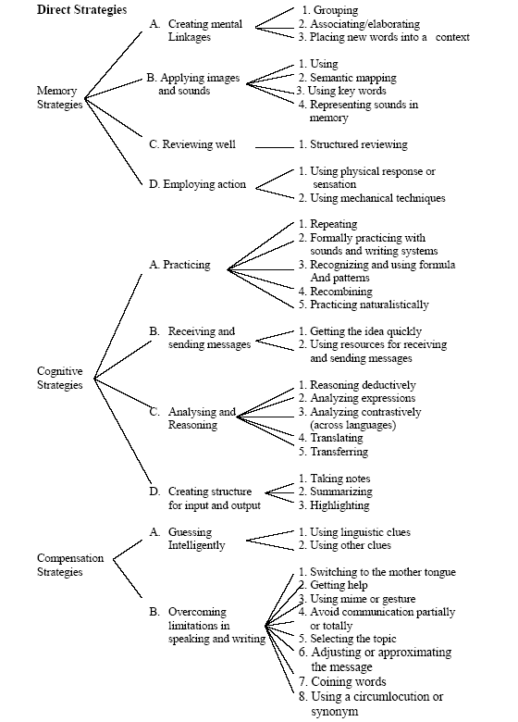
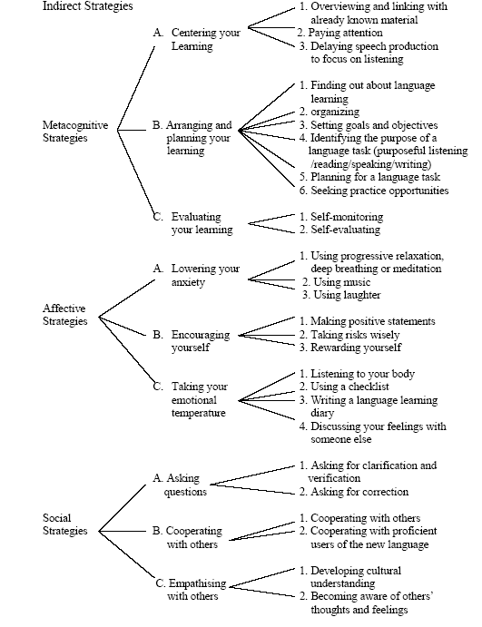
Figure I: Diagram of Oxford’s Strategy Classification System
(Oxford, 1990, pp. 18-21)
  - Findings of Similar research
Research suggests that more proficient language learners use more learning strategies and more types of strategies than less proficient language learners (Altan, 2003; Green &Oxford, 1995; Naiman, Fröhlich, Stern, & Todesco, 1978; Oxford, 1985; Rubin, 1975, 1981; Stern, 1983; Wharton, 2000) and are better able to choose strategies appropriate to the task (Vann & Abraham, 1990). The types of language learning strategies used by different learners vary according to many variables including motivation, gender, type of task, age, subject matter, level of L2, learning style, and cultural background (Oxford, 1989). Despite the fact that certain types of learners defined by cultural background are predisposed to use certain types of strategies, it is difficult to say that research findings have completely explored the effects of cultural background in determining strategy preferences. The main finding in Bedell's (1993) study cited in Oxford, et. al. (1995) was that different cultural groups use particular kinds of strategies at different levels of frequency. According to Politzer and McGroarty (1985), Asian students tend to prefer rote memorization strategies and rule-oriented strategies. Oxford (1994) found that Taiwanese students seem far more structured, analytic, memory-based, and metacognitively oriented than other groups. McGroarty (1987) cited in Oxford, et. al. (1995) found that Spanish learners use highly traditional strategies such as using a dictionary to learn words. Similarly, O Malley and Chamot (1990) found that students of Asian background prefer their own established rote learning strategies. Correspondingly, Huang & Van Naerrsen (1987); Tyacke & Mendelsohn (1986) point out that Asian learners prefer strategies including rote memorization and a focus on the linguistic code. According to O’Malley et al. (1985) Asian learners also showed more reluctance than Hispanic learners to try new learning techniques. The use of strategies that are different from those used by other cultural groups led Politzer and Mc Groarty (1985) to conclude that many accepted “good” language-learning strategies may be based on ethnocentric assumptions, namely Western, about effective language learning.

